**Practical 1**

**AIM:** Study of basic elements of computer networking devices.

**REQUIREMENTS:**

A thorough and functional understanding of computer networking necessitates both theoretical knowledge and practical familiarity with the following essential components, systems, and tools.

**1. Core Networking Hardware (The Physical Infrastructure):**

* **Router:** An intelligent device essential for connecting disparate networks and enabling communication between them (e.g., connecting a home network to the global internet).
* **Switch:** A central connectivity device used to build a Local Area Network (LAN) by intelligently forwarding data between connected devices.
* **Hub:** An obsolete, non-intelligent legacy device once used for LAN connectivity, now studied for historical context and to understand the evolution of network technology.
* **Modem (Modulator-Demodulator):** A crucial device that translates digital signals from a computer into analog signals for transmission over the ISP's infrastructure, and vice-versa.
* **Wireless Access Point (WAP):** A device that provides wireless network connectivity (Wi-Fi) by acting as a bridge between wireless devices and a wired network.
* **Firewall:** A critical security appliance or software application that enforces network security policies by filtering incoming and outgoing traffic.

**2. Transmission Media (The Data Highways):**

* **Unshielded Twisted Pair (UTP) Cable:** The most prevalent form of copper cabling in modern LANs, utilizing twisted wire pairs for signal integrity. Requires RJ45 connectors.
* **Coaxial Cable:** A type of copper cable with enhanced shielding, primarily used for broadband internet and cable television distribution. Utilizes BNC or F-type connectors.
* **Fiber Optic Cable:** A high-performance medium that transmits data as pulses of light through glass strands, offering the highest speeds and bandwidth. Common connectors include SC, LC, and ST.

**3. Network Topologies (The Architectural Blueprints):**

* **Star Topology:** A centralized layout where all devices connect to a single central point.
* **Bus Topology:** A linear layout where all devices share a single common cable.
* **Ring Topology:** A circular layout where each device is connected to two neighbors.
* **Mesh Topology:** A highly interconnected layout providing redundant paths for data.
* **Hybrid Topology:** A composite architecture that combines two or more basic topologies.

**4. System and Software Prerequisites:**

* **Operating System:** A modern OS such as Windows 10/11, any major Linux distribution (e.g., Ubuntu, Fedora), or macOS, all of which have built-in networking stacks.
* **Command-Line Interface (CLI):** Command Prompt (CMD) or PowerShell on Windows; the Terminal on macOS and Linux systems for executing network commands.
* **Web Browser:** An essential tool for verifying internet connectivity, accessing the web-based configuration interfaces of routers and other devices, and performing online speed tests.
* **Network Simulation Software (Optional but Recommended):** For advanced study, tools like Cisco Packet Tracer or GNS3 allow for the creation and testing of complex virtual network environments without physical hardware.

**5. Essential Network Diagnostic and Troubleshooting Commands:**

This table provides a summary of the most critical command-line utilities for network analysis.

| Command | Detailed Description & Use Case |
| --- | --- |
| **ping** | **Purpose:** Tests the reachability of a host on an IP network. **Mechanism:** It sends Internet Control Message Protocol (ICMP) "Echo Request" packets to the specified destination and waits for an ICMP "Echo Reply". **Output Analysis:** It reports the round-trip time for each packet, packet loss, and TTL (Time to Live), providing a quick and effective measure of network latency and connectivity. |
| **ipconfig / ifconfig** | **Purpose:** Displays the fundamental IP configuration of all network interfaces on a system. **Mechanism:** It queries the operating system's network stack for details on each network adapter. **Key Information Provided:** IP Address, Subnet Mask, Default Gateway, DNS Servers, and MAC Address. (ifconfig is the command for Linux/macOS, while ipconfig is for Windows). |
| **tracert / traceroute** | **Purpose:** Traces the network path (the sequence of routers) that a packet takes to reach a destination. **Mechanism:** It sends packets with incrementally increasing TTL values. Each router ("hop") along the path decrements the TTL. When the TTL reaches zero, the router sends back an ICMP "Time Exceeded" message, revealing its IP address. This process is repeated until the destination is reached. |
| **netstat** | **Purpose:** Provides a comprehensive overview of network activity. **Mechanism:** It inspects the operating system's network connection tables. **Common Uses:** netstat -an will display all active TCP and UDP connections, listening ports, and the foreign addresses they are connected to. It is invaluable for identifying what services are running and what connections are being made by your computer. |
| **nslookup** | **Purpose:** A utility for querying the Domain Name System (DNS) to resolve domain names to IP addresses and vice-versa. **Mechanism:** It sends a query to the configured DNS server. **Use Case:** Essential for diagnosing DNS-related problems. If you can ping an IP address like 8.8.8.8 but cannot access https://www.google.com/search?q=google.com, the issue is likely with DNS, and nslookup can help confirm this. |
| **arp -a** | **Purpose:** Displays and modifies the Address Resolution Protocol (ARP) cache. **Mechanism:** On a local Ethernet network, devices use MAC addresses to communicate. ARP is the protocol used to map a known IP address to its corresponding MAC address. The arp -a command shows the current table of these mappings that your computer has learned. |
| **route print** | **Purpose:** Displays the local IP routing table. **Mechanism:** This table is a set of rules, much like a road map, that the operating system uses to decide where to send outgoing packets based on their destination IP address. The "Default Gateway" is the most important entry, as it's the path packets take to reach any destination outside the local network. |

Export to Sheets

**THEORY: An In-Depth Exploration**

**1. Detailed Analysis of Core Networking Devices**

Networking devices are the specialized hardware that direct and control the flow of data across a network. They operate at different layers of the conceptual OSI (Open Systems Interconnection) model.

**Router (OSI Layer 3 - Network Layer)**

A router is fundamentally a traffic director for computer networks. Its primary purpose is to connect different logical networks together—for example, your Local Area Network (LAN) in your home to your Internet Service Provider's (ISP) Wide Area Network (WAN).

* **How it Works:** Routers make decisions based on **IP addresses**. Every data packet that traverses a network has a source and destination IP address. When a router receives a packet, it inspects the destination IP address and consults its internal **routing table**. This table contains a list of network addresses and the best "path" or "next hop" to reach them. Based on this information, the router forwards the packet to the next router in the path, or to the final destination if it's on a directly connected network. This process of choosing the best path is called **routing**.
* **Key Functions:**
  + **Path Determination:** Intelligently selects the most efficient route for data.
  + **Packet Forwarding:** Moves data packets between different networks.
  + **Broadcast Domain Separation:** Routers, by their nature, do not forward broadcast traffic from one network to another, which prevents network-wide "storms" of traffic and improves efficiency.
* **Modern Context:** The "router" in most homes is a multi-function device, combining a router, a network switch, a wireless access point, and a basic firewall into a single consumer-grade unit.

**Switch (OSI Layer 2 - Data Link Layer)**

A switch is the central connection point for devices on a single Local Area Network (LAN). It is a vast improvement over its predecessor, the hub.

* **How it Works:** A switch operates using **MAC addresses** (Media Access Control addresses), which are unique hardware identifiers baked into every network interface card (NIC). When a device is connected to a switch, the switch learns its MAC address and associates it with the physical port it's plugged into. It stores this information in a **MAC address table** (also called a CAM table). When a data frame arrives at the switch, the switch examines the destination MAC address, looks it up in its table, and creates a direct, temporary connection only to the port of the intended recipient. It forwards the frame exclusively to that destination port.
* **Key Advantage over Hubs:** This intelligent forwarding is the key difference. A hub would have broadcast the frame to every single device on the network, creating unnecessary traffic and collisions. A switch creates a dedicated path, allowing many devices to communicate simultaneously without interfering with each other. This is known as creating separate **collision domains**.
* **Types:** Switches can be **unmanaged** (simple plug-and-play devices) or **managed** (offering advanced configuration options like VLANs, QoS, and port security for enterprise environments).

**Hub (OSI Layer 1 - Physical Layer)**

A hub is an obsolete networking device that serves as a common connection point for devices in a network. It is essentially a "dumb" multi-port repeater.

* **How it Works:** A hub operates at the physical layer, meaning it has no concept of MAC or IP addresses. When an electrical signal (a data bit) comes in on one port, the hub simply regenerates and repeats that signal out of **every other port**.
* **The Problem:** Because every piece of data is broadcast to every device, all devices on the hub share the same bandwidth and exist in a **single collision domain**. If two devices try to send data at the same time, their signals "collide" on the network, corrupting the data and forcing them to re-transmit. This makes hubs incredibly inefficient, especially as more devices are added. They have been entirely superseded by switches in all modern network designs.

**Modem (Modulator-Demodulator)**

A modem is the bridge between the digital world of your computer network and the analog world of your ISP's infrastructure (which could be telephone lines, coaxial cable, or fiber optics).

* **How it Works:** The name explains its function.
  + **Modulation:** It takes the outgoing digital data stream from your router (ones and zeros) and **modulates** it onto an analog carrier signal suitable for transmission over the ISP's physical lines.
  + **Demodulation:** It receives incoming analog signals from the ISP and **demodulates** them, converting them back into a clean digital data stream that your router and computer can understand.
* **Types:** Modems are specific to the type of internet service: DSL modems for phone lines, Cable modems for coaxial TV lines, and ONTs (Optical Network Terminals) for fiber optic service.

**Wireless Access Point (WAP)**

A WAP is a device that allows wireless-capable devices (laptops, smartphones, etc.) to connect to a wired network using Wi-Fi (the IEEE 802.11 standards).

* **How it Works:** A WAP acts as a central transmitter and receiver of wireless radio signals. It is essentially a bridge that connects the wireless LAN (WLAN) to a wired Ethernet LAN. Devices connect to the WAP, which then relays their traffic to the rest of the network via its physical connection to a switch or router. In home environments, WAP functionality is almost always integrated directly into the main router. In large corporate or campus environments, many standalone WAPs are strategically placed to provide seamless coverage.

**Firewall**

A firewall is a network security system that acts as a protective barrier between a trusted network (e.g., your home LAN) and an untrusted network (e.g., the internet).

* **How it Works:** It monitors and controls all incoming and outgoing network traffic based on a defined set of security rules. At its most basic, a firewall works by **packet filtering**. It inspects the headers of each packet—looking at source/destination IP addresses, ports, and protocols—and decides whether to allow it or block it based on its Access Control List (ACL).
* **Stateful vs. Stateless:**
  + **Stateless:** Examines each packet in isolation, with no context of previous packets.
  + **Stateful:** More advanced. It keeps track of active connections (the "state" of the connection). It knows if a packet is part of an existing, legitimate conversation (e.g., a response you requested from a website) and is more intelligent about what traffic to permit.
* **Implementation:** A firewall can be a dedicated hardware device or a software application running on a host computer (like Windows Defender Firewall).

**2. In-depth Look at Transmission Media**

Transmission media are the physical channels through which data is transmitted. The choice of medium impacts speed, distance, cost, and security.

**Unshielded Twisted Pair (UTP) Cable**

This is the workhorse of modern wired networking.

* **Construction:** UTP consists of four pairs of thin, color-coded copper wires. Each pair is twisted together. This twisting is the critical design feature: it creates a magnetic field that cancels out electromagnetic interference (EMI) and crosstalk from adjacent pairs and external sources (like power lines or fluorescent lights).
* **Categories:** UTP cables are graded into categories based on their performance:
  + **Cat 5e (Enhanced):** Supports speeds up to 1 Gbps. The minimum standard for modern networks.
  + **Cat 6:** Supports speeds up to 10 Gbps over shorter distances (up to 55 meters). Has more twists and better shielding than Cat 5e.
  + **Cat 6a (Augmented):** Supports 10 Gbps over the full 100-meter distance. Even better shielding and construction.
* **Connectors:** UTP cables are terminated with **RJ45** connectors.

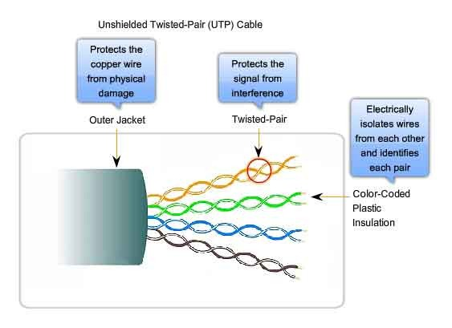

**Coaxial Cable**

Coaxial cable, or "coax," is designed for robust signal transmission with high resistance to interference.

* **Construction:** It has a layered structure:
  1. A central solid copper conductor.
  2. A dielectric plastic insulator surrounding the core.
  3. A braided metal shield (copper or aluminum) that blocks EMI.
  4. An outer plastic sheath for protection.
* **Use Cases:** While it was used in early bus topology Ethernet networks (e.g., 10BASE2), its primary modern use is by cable television companies to deliver broadband internet and TV signals to homes. The shielding is essential for maintaining signal integrity over the longer distances from the street to a house.

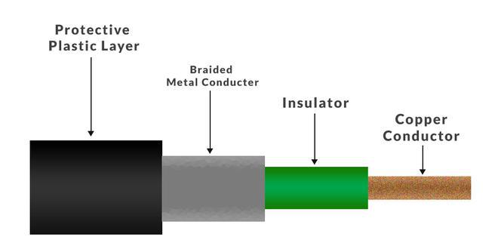

**Fiber Optic Cable**

Fiber optics represents the pinnacle of data transmission technology.

* **Construction:** It consists of a core made of hair-thin strands of pure glass or plastic, a cladding layer that reflects light back into the core, and a protective outer jacket. Data is transmitted as modulated pulses of light generated by either an LED or a laser.
* **How it Works:** The principle of **total internal reflection** keeps the light signals bouncing down the core with minimal loss of strength, even around gentle bends. Since it uses light instead of electricity, it is completely immune to EMI and radio frequency interference (RFI).
* **Types:**
  + **Multi-Mode Fiber (MMF):** Has a larger core, uses LEDs, and is used for shorter distances (e.g., within a data center or campus) as the light disperses more over distance.
  + **Single-Mode Fiber (SMF):** Has an extremely thin core, uses lasers, and can transmit data for many kilometers with virtually no signal degradation. It is the backbone of the global internet, running under oceans to connect continents.
* **Advantages:** Extremely high bandwidth, long-distance capability, enhanced security (very difficult to tap into without being detected), and immunity to electrical interference.

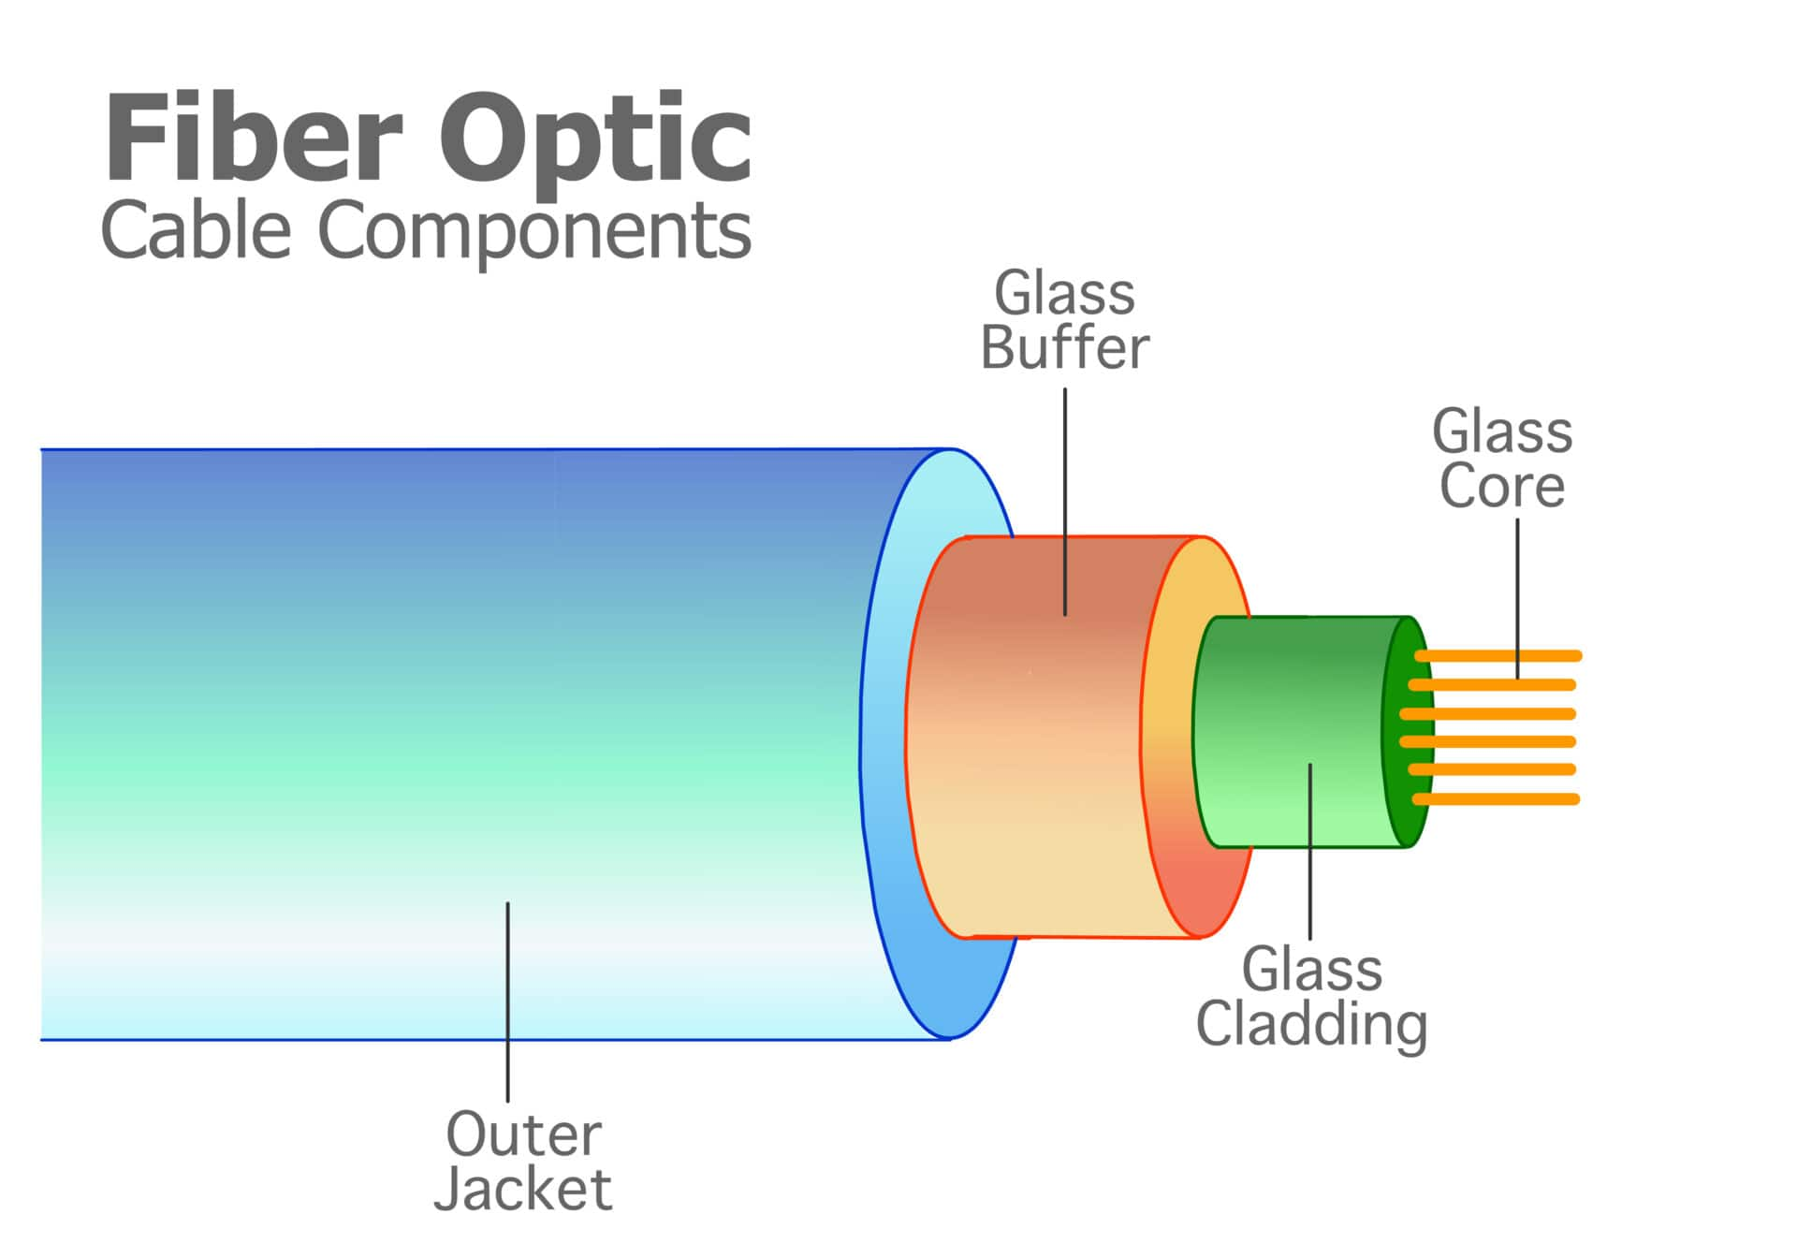

**3. Understanding Network Topologies in Detail**

A topology is the schematic description of a network's arrangement, defining how nodes are connected and how data flows.

**Star Topology**

In a star topology, every end device (like a computer or printer) is connected to a central intermediate device, typically a switch.

* **Data Flow:** When one computer wants to send data to another, it sends the data to the central switch. The switch then forwards the data only to the intended destination device.
* **Advantages:**
  + **Reliability:** A failure in a single cable or non-central device does not affect the rest of the network.
  + **Scalability:** Easy to add or remove devices without disrupting the network.
  + **Easy Troubleshooting:** It's easy to isolate faults to a specific cable or device.
* **Disadvantages:**
  + **Single Point of Failure:** If the central switch fails, the entire network connected to it goes down.
  + **Cost:** Requires more cabling than a bus topology.
* **Use Case:** The de facto standard for virtually all modern LANs.

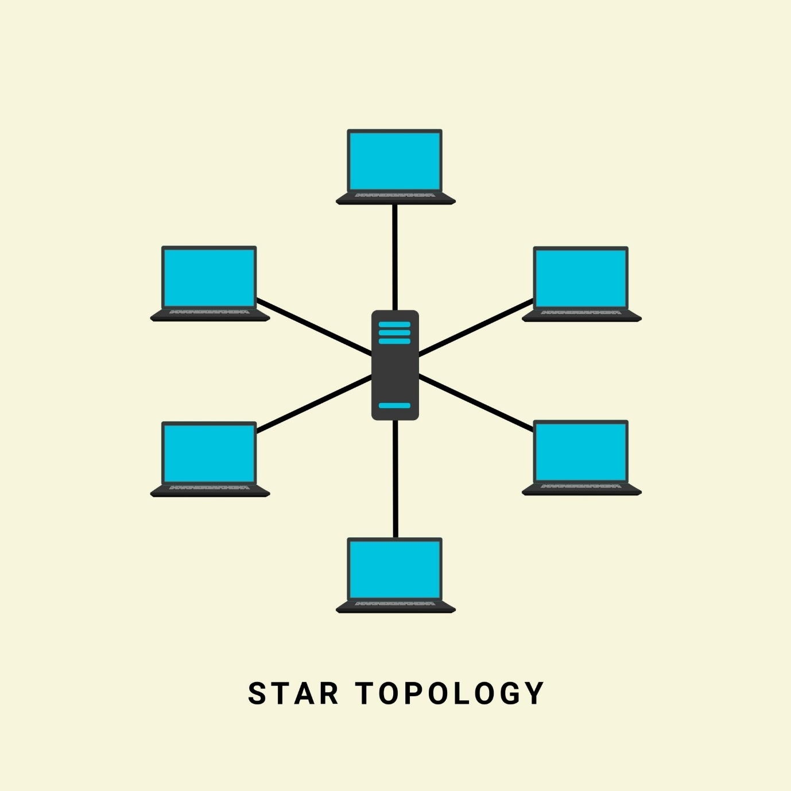

Licensed by Google

**Bus Topology**

An obsolete topology where all devices are connected to a single shared cable, known as the backbone or bus.

* **Data Flow:** When a device transmits, the signal travels the entire length of the bus in both directions. Every other device on the bus "hears" the signal but only the device with the matching destination address accepts it. **Terminators** are required at both ends of the backbone to absorb the signal and prevent it from reflecting back.
* **Advantages:**
  + **Low Cost:** Requires minimal cabling.
* **Disadvantages:**
  + **Difficult Troubleshooting:** A break anywhere in the main cable is hard to locate and will bring down the entire network.
  + **High Collision Rate:** Since all devices share the same cable, collisions are frequent, and performance degrades rapidly as more devices are added.
  + **Low Scalability:** Difficult to add new devices without temporarily disrupting the network.

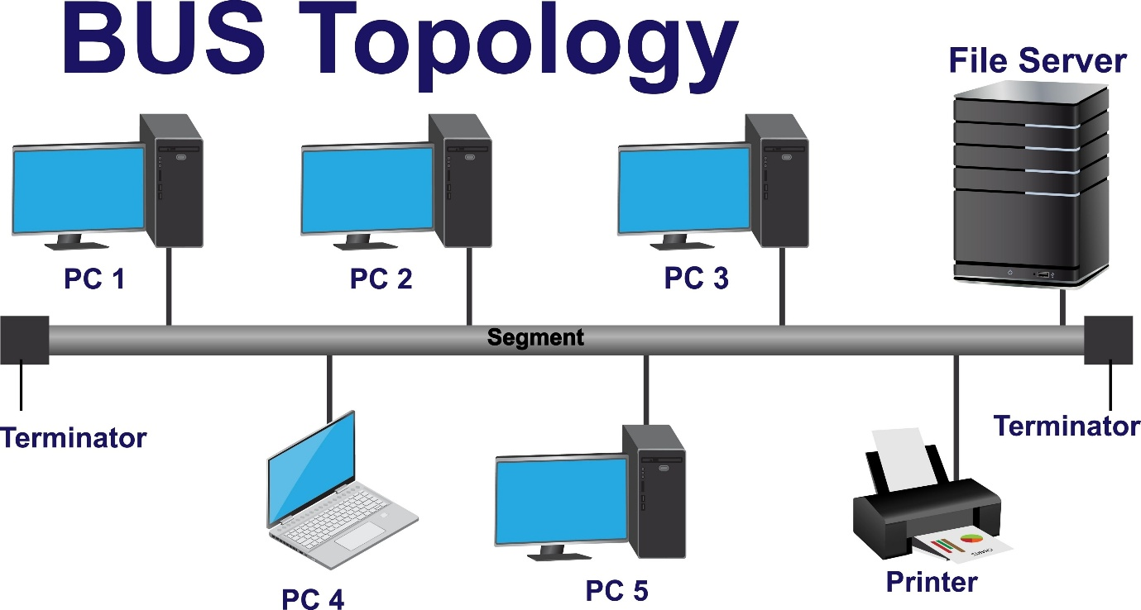

Licensed by Google

**Ring Topology**

In a ring topology, devices are connected in a circle, with each device connected directly to two others.

* **Data Flow:** Data typically travels in one direction. A "token passing" mechanism is often used to prevent collisions. A special frame called a token circulates the ring. A device can only transmit data if it possesses the token. This ensures only one device sends data at a time.
* **Advantages:**
  + **Orderly Traffic:** The token passing method eliminates data collisions.
* **Disadvantages:**
  + **Single Point of Failure:** The failure of one device or one segment of cable can break the entire ring (though dual-ring configurations can mitigate this).
  + **Difficult to Reconfigure:** Adding or removing a device requires breaking the ring.

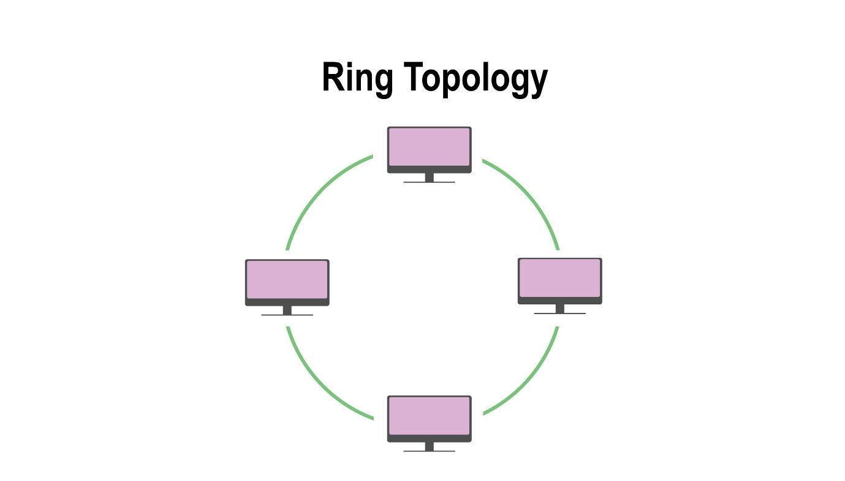

Licensed by Google

**Mesh Topology**

A mesh topology is characterized by its high level of interconnectivity, providing redundant paths for data.

* **Types:**
  + **Full Mesh:** Every single node is connected directly to every other node. The number of connections is n(n-1)/2, where n is the number of nodes.
  + **Partial Mesh:** Some nodes are fully interconnected, while others are only connected to one or two other nodes.
* **Data Flow:** Data can be sent along many different paths. The network can dynamically reroute traffic if one path becomes congested or fails.
* **Advantages:**
  + **Extreme Fault Tolerance:** The failure of a single link or node has little impact on the network as a whole.
  + **High Performance:** Dedicated point-to-point links can handle high traffic loads.
* **Disadvantages:**
  + **Extremely High Cost and Complexity:** The amount of cabling and number of network ports required for a full mesh is prohibitively expensive and difficult to manage.
* **Use Case:** The internet's core infrastructure is a massive partial mesh network, providing the robustness needed for a global communication system.

**Hybrid Topology**

A hybrid topology is any network that combines two or more different base topologies. This is the most common approach in real-world, large-scale networks.

* **Example:** A common example is a **Star-Bus** topology. A university campus might have a high-speed bus backbone connecting different buildings. Within each building, the network is a star topology with all devices connected to a central switch.
* **Advantages:**
  + **Flexibility and Scalability:** Allows network designers to use the most appropriate topology for a specific part of the network while still connecting everything.
* **Disadvantages:**
  + **Increased Complexity:** Can be more complex to design, implement, and manage than a single base topology.

**CONCLUSION:**

This exhaustive study reveals that a computer network is not a single entity but a complex, synergistic system of interdependent layers. The physical devices—routers, switches, and modems—act as the intelligent nervous system, directing data with precision. The transmission media—from copper UTP to fiber optic strands—form the circulatory system, the physical pathways through which information flows. The network topologies provide the architectural skeleton, defining the structure and resilience of the network.

A mastery of these theoretical concepts is incomplete without the practical ability to diagnose and manage a network. The command-line utilities explored, such as ping, tracert, and netstat, are the essential diagnostic tools of a network professional. They allow one to query the health of the network, trace the flow of data, and identify problems in real-time. Therefore, a deep understanding of both the "what" (the components) and the "how" (the diagnostic tools) is absolutely fundamental to designing, building, securing, and maintaining the robust and efficient networks that underpin our modern digital world.